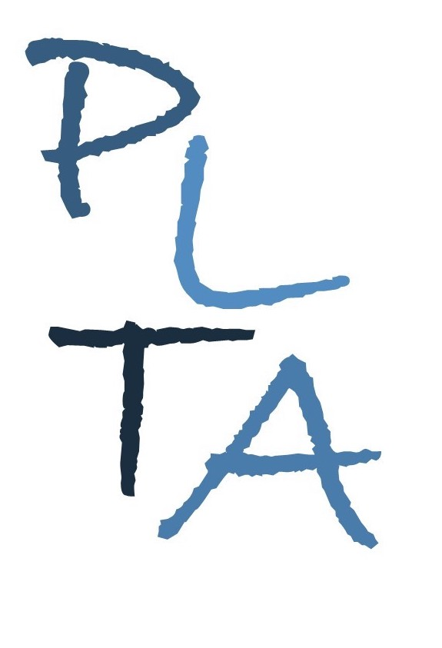
.
PETERBOROUGH LEARNING & TEACHING ASSOCIATES
ALISON CARROLL ANDY HAWES SUZIE JULIEN

Committed to excellence in learning, teaching and leadership

Literacy in the EYFS
For Reception NQTs new to Reception teachers and TAs
This course will provide delegates with the opportunity to enhance their understanding of the EYFS Statutory requirements for Literacy, underpinned by the requirements for Communication and Language. In addition to exploring key concepts and skills, delegates will consider implications for learning environments, resources and adult support. The course will be delivered over 2 half days and 1 twilight follow up session.
As a result of attending this course, delegates will have developed their understanding of:
- The statutory EYFS requirements for Communication & Language and Literacy;
- The development of early reading and writing skills;
- Key elements and strategies for practice;
- The role of the adult in supporting and inspiring young children on their journey to becoming readers and writers

All delegates must bring a copy of:
- EYFS Statutory Framework
- EYFS Development Matters
- EYFS Profile Exemplification materials for Communication & Language and Literacy

Course Leader: Al Carroll
Venue: This course can be delivered online or in a host school
Cost: £125 per delegate

Please contact Al T: 07815065071 / E: alisonruthcarroll@gmail.com to discuss options to suit your school Venue: This course can be delivered online or in a host school. * Please note, an adapted version of this course is available for Early Adopter schools.

Cancellation charges (unless due to illness):
With less than 5 working days’ notice: 25% charge
With at least 5 working days’ notice: no charge

Non-attendance (unless due to illness): 50% charge
www.plta.co.uk

