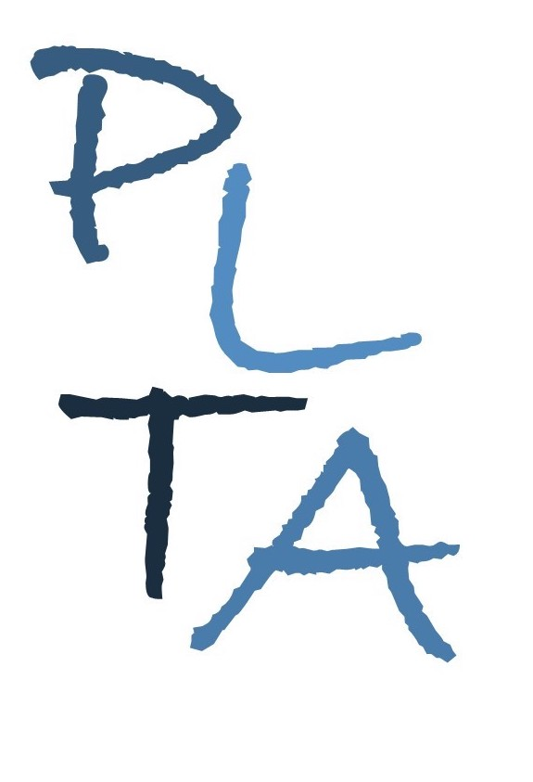
.
PETERBOROUGH LEARNING & TEACHING ASSOCIATES
Committed to excellence in learning, teaching and leadership
www.plta.co.uk
Making, doing, using :
Exploring children’s creativity

Format: Inhouse whole team training for your setting
Audience: Practitioners working in preschools and nurseries (preschool rooms)
We can’t all be Van Gogh or Bansky and we won’t all star in Britain’s Got Talent, but we are all creative in some way… This course will provide delegates with the opportunity to enhance their understanding of and provision for both aspects of Expressive Arts and Design. In addition to exploring key concepts and skills, delegates will consider implications for learning environments, resources and adult support.

This course is specifically designed to suit the needs of the settings. It can be delivered during daytime/evenings/Saturdays or school holidays to facilitate as wide an audience as possible, within a setting or group of settings. The course consists of 2, two and a half hour sessions, with gap tasks between and could be followed by a visit to the setting to support staff with implementation of aspects of the course. The course can be run for a minimum of 5 and a maximum of 30 delegates. Prices vary according to the number of delegates.

As a result of attending this course, delegates will have developed their understanding of:
- The statutory EYFS requirements for Expressive Arts & Design and linked areas of learning;
- Key elements for practice and provision;
- The role of the adults in helping children to be creative and imaginative learners;
- How Expressive Arts & Design links to other areas of learning.
All delegates must bring a copy of:
- EYFS Statutory Framework
- EYFS Development Matters

Course Leaders: Al Carroll and Kathryn Gray

How to book: Please contact Al by email or phone
E: alisonruthcarroll@gmail.co.uk
T: 07815065071
Total cost for the course (2 sessions):
Standard charge £399 plus the following delegate costs:
- Minimum of 5: £40 person
- Minimum of 10: £35 per person
- Minimum of 15: £30 per person

On receipt of booking, settings will be invoiced for a deposit of £200. This deposit should be paid prior to the 1st session.

Cancellation charges (unless due to illness):
With less than 3 working days’ notice - 50% charge
With at least 3 working days’ notice - no charge

