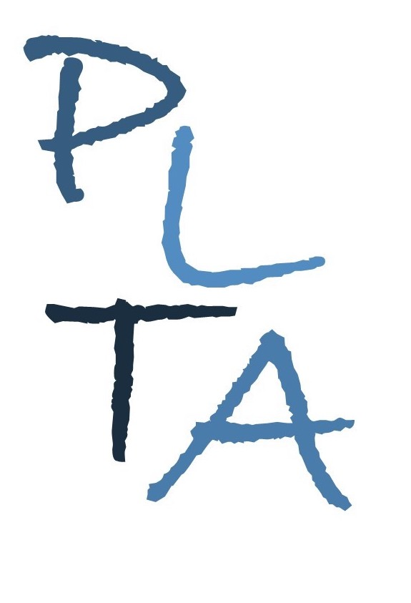
.
PETERBOROUGH LEARNING & TEACHING ASSOCIATES
ALISON CARROLL ANDY HAWES SUZIE JULIEN

Committed to excellence in learning, teaching and leadership

TA toolkit: Supporting children’s learning in the EYFS
Audience: This course is suitable for TAs new to working in the EYFS or for more experienced TAs who want to refresh their knowledge and skills
This course will provide delegates with the opportunity to develop their understanding of how to support children’s learning, by considering child development, effective pedagogy and learning & teaching strategies. In addition to exploring statutory requirements, key concepts and skills, delegates will consider implications for the learning environments, resources and the adult role. The course will be delivered over 3 half day sessions (with gap tasks between) and then followed by a visit to each delegates school. The focus for the visit will be agreed with each individual and their school.

As a result of attending this course, delegates will develop their understanding of:
- The EYFS Statutory Framework and Development Matters
- How children learn
- The role of the adults (how to effectively support children's learning across the areas of learning)
- Continuous provision and adult led activities
- Effective observation and assessment practice
All delegates must bring a copy of:
- EYFS Statutory Framework
- EYFS Development Matters

Course Leader: Al Carroll

Date, venues and cost TBC

How to book: Please contact Al by email or phone
E: alisonruthcarroll@gmail.co.uk
T: 07815065071

www.plta.co.uk

