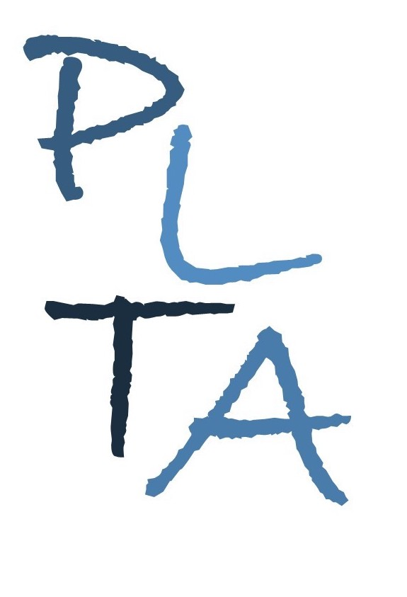
.
PETERBOROUGH LEARNING & TEACHING ASSOCIATES
ALISON CARROLL ANDY HAWES SUZIE JULIEN

Committed to excellence in learning, teaching and leadership

Developing Practice – Expressive Arts & Design
For all EYFS practitioners working in Reception classes or maintained nurseries
Providing for the breadth of knowledge and skill development in this area of learning can be challenging. The drive to improve Literacy and Maths attainment can also lead, unnecessarily, to a reduced focus on this area of learning. Attendance at this course will provide delegates with the opportunity to enhance their understanding of and provision for effective teaching of the ‘Expressive Arts and Design’ area of learning in the EYFS and how it links to other areas such as Moving & Handling, Literacy and Maths. Delegates will be equipped with ideas and resources to use in their classrooms. The course will be delivered over 1 half day and 1 twilight session.
As a result of attending this course, delegates will further develop their understanding of:
- The statutory EYFS requirements for Understanding of the World and how it links and supports other areas of learning, such as literacy and maths;
- How to effectively plan for this area of learning
- Key elements for practice and provision;

All delegates must bring a copy of:
- EYFS Statutory Framework
- EYFS Development Matters
- EYFS Profile Exemplification materials for Expressive Arts & Design, Moving & Handling, Speaking, Literacy and Mathematical Development

Course Leader: Al Carroll

Venue: This course can be delivered online or in a host school

Cost: £125 per delegate

Please contact Al T: 07815065071 / E: alisonruthcarroll@gmail.com to discuss options to suit your school. * Please note, an adapted version of this course is available for Early Adopter schools.

Cancellation charges (unless due to illness):
With less than 5 working days’ notice: 25% charge
With at least 5 working days’ notice: no charge
Non-attendance (unless due to illness): 50% charge

