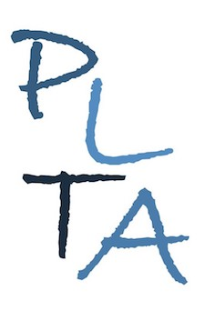
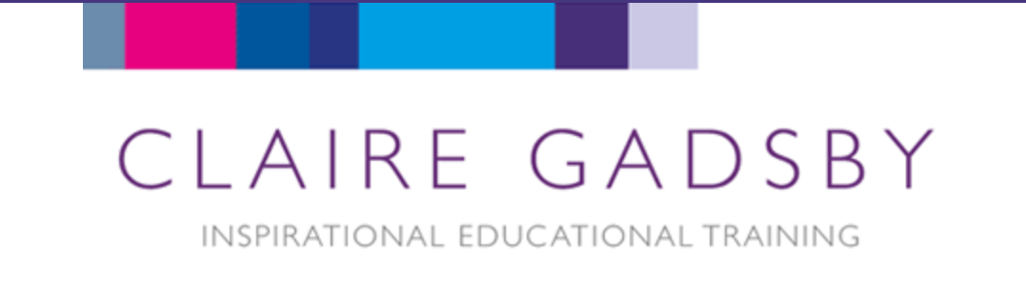

Peterborough Learning & Teaching Associates

How To Be a Great Teacher and Still Have a Life!

Not enough hours in the day?
Just too much to do to keep on top of things?

Why not join PLTA and internationally renowned educational consultant and author Claire Gadsby for a webinar filled with inspirational, practical and time-saving tips that you can implement in your classroom tomorrow!

Who: Teachers from YR to Y6
When: Early 2022 – date tbc
Platform: Microsoft Teams
Cost: £45 for the first and £40 for the second and subsequent delegates from the same school.

Booking: Please book via the booking form on the PLTA website: www.plta.co.uk/booking-form

www.plta.co.uk www.clairegadsby.com

