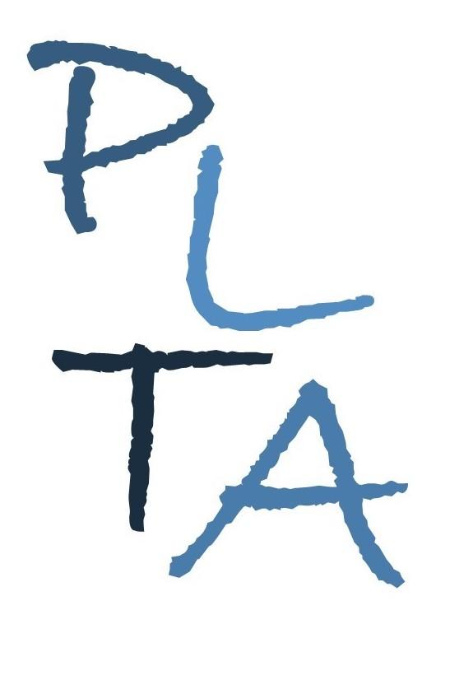
.
PETERBOROUGH LEARNING & TEACHING ASSOCIATES
ALISON CARROLL, ANDY HAWES & SUZIE JULIEN

Committed to excellence in learning, teaching and leadership

Continuing the Learning Journey from EYFS into Y1
A multi-session package for teachers working in Year 1 from September 2019

The package consists of 1 full day’s training and four twilight network meetings led and facilitated by PLTA advisers. The overall foci includes:
- Ensuring that practice in Y1 enables effective transition from EYFS and into Y2;
- Sharing good practice;
- Generic pedagogy and subject-specific elements.
There is also the option of a 2 hour follow up visit to support individual delegate’s in their own school.

Twilight 1: Tuesday 8th October 2019 16:00 - 17:30
Focus: Provision & Planning (Venue: Gunthorpe Primary School)
Session 2: Tuesday 19th November 2019 16:00 - 17:30
Focus: Mathematics (Venue Castor Primary School)
Session 3: Thursday 30th January 2020 16:00 - 17:30
Focus: English (Venue Ravensthorpe Primary School)
Session 4: Tuesday 5th May 2020 16:00 - 17:30
Focus: Making the most of the summer term – overcoming barriers and planning for effective transition (Venue Queen’s Drive Infant School)
Optional follow up visit can be arranged at any point during the year. Please email us for further details.
Cost: £40 per delegate per session
SPECIAL OFFER: Schools with multiple Y1 teachers can send second and subsequent delegates for the reduced cost of £30 per session. Attendance at all 4 twilights will be charged at £150 for the first delegate and £100 for second and subsequent delegates.

To make a booking, please email Peterboroughlta@gmail.com

Cancellation charges:
- Bookings cancelled after 14th June will incur a full charge
- Non-attendance on the day will incur a full charge.
- There is no cost for a substitution.

www.plta.co.uk

